Module Name: Library Management System - Functional & UI Test Cases

Test Case ID: TC001 - TC005

WEBSITE URL: https://cheerful-sfogliatella-731734.netlify.app/hhttps://cheerful-sfogliatella-731734.netlify.app/https://cheerful-sfogliatella-731734.netlify.app/ttps://cheerful-sfogliatella-731734.netlify.app
● Scenario ID: TC001
Scenario: Register member with valid details
Test Steps:
- 1. Open Member Registration
- 2. Enter all required fields
- 3. Click Register
Test Input: Name: Asha Patel; Email: asha@test.com; Phone: 9876543210
Expected Result: Member registered successfully
Actual Result: Member registered successfully with the entered valid details.
Status: Pass
Comments: Positive flow with valid details
Screenshots:
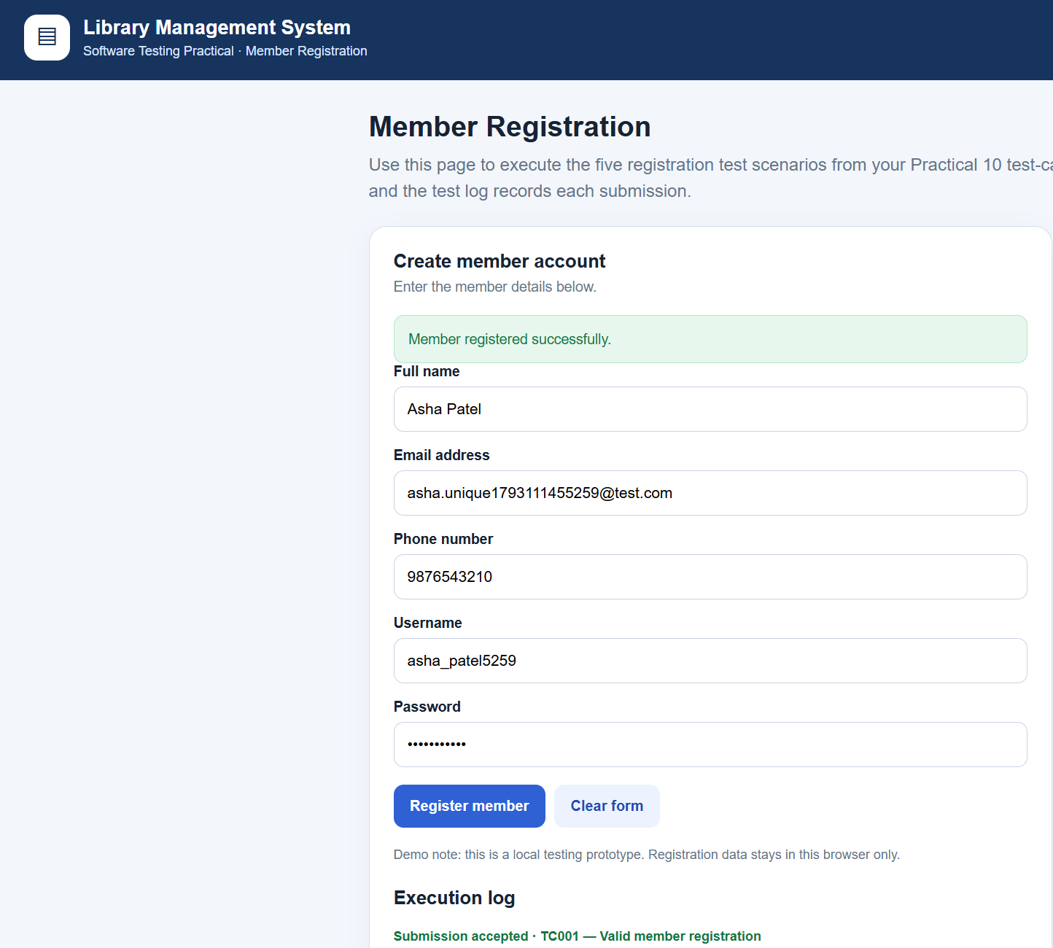
● Scenario ID: TC002
Scenario: Register member with already registered email
Test Steps:
- 1. Open Member Registration
- 2. Enter an existing email
- 3. Fill other fields
- 4. Click Register
Test Input: Email: asha@test.com (already used)
Expected Result: Error shown: email already in use; registration blocked
Actual Result: Duplicate email was rejected and an email-already-in-use message was displayed.
Status: Pass
Comments: Duplicate-record validation
Screenshots:
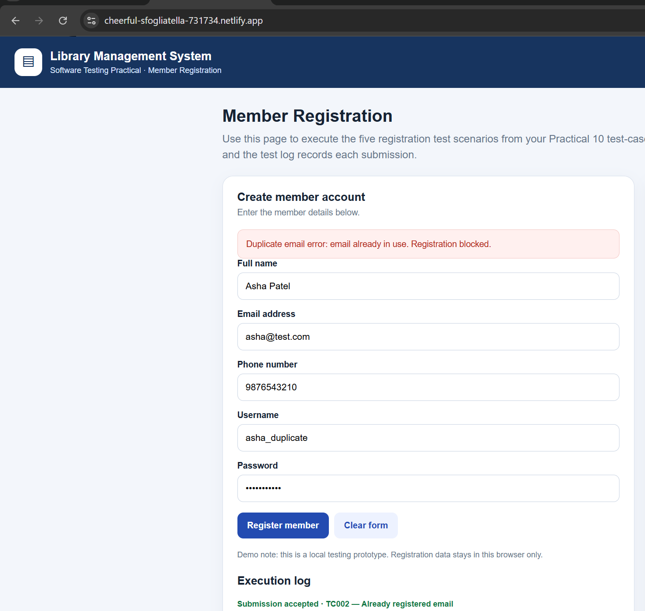

● Scenario ID: TC003
Scenario: Register member with empty name
Test Steps:
- 1. Open Member Registration
- 2. Leave Name blank
- 3. Fill other fields
- 4. Click Register
Test Input: Name: blank
Expected Result: Error "Name is required"; registration blocked
Actual Result: Registration was blocked and the required-name validation message was displayed.
Status: Pass
Comments: Required-field validation
Screenshots:
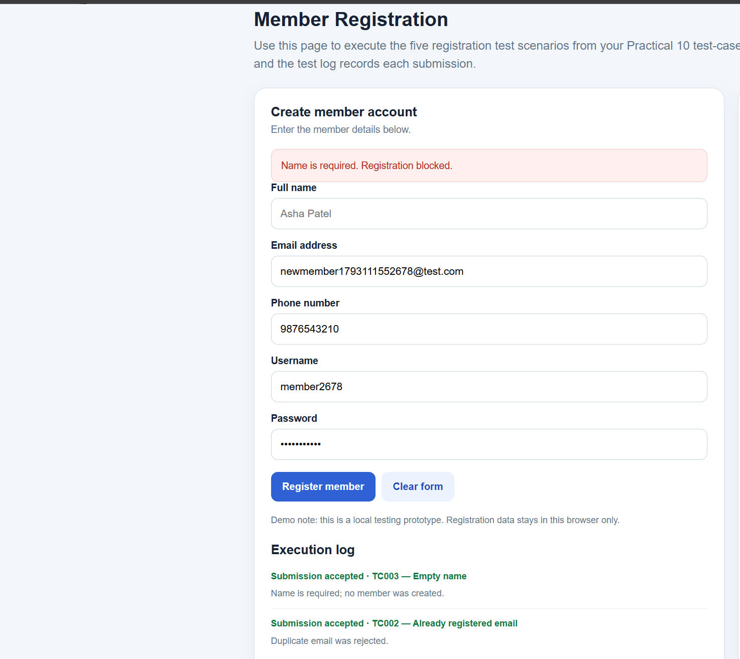
● Scenario ID: TC004
Scenario: Register member with invalid phone number
Test Steps:
- 1. Open Member Registration
- 2. Enter phone with fewer than 10 digits
- 3. Click Register
Test Input: Phone: 12345
Expected Result: Error "Invalid phone number"; registration blocked
Actual Result: Registration was blocked and an invalid-phone-number message was displayed.
Status: Pass
Comments: Phone format validation
Screenshots:

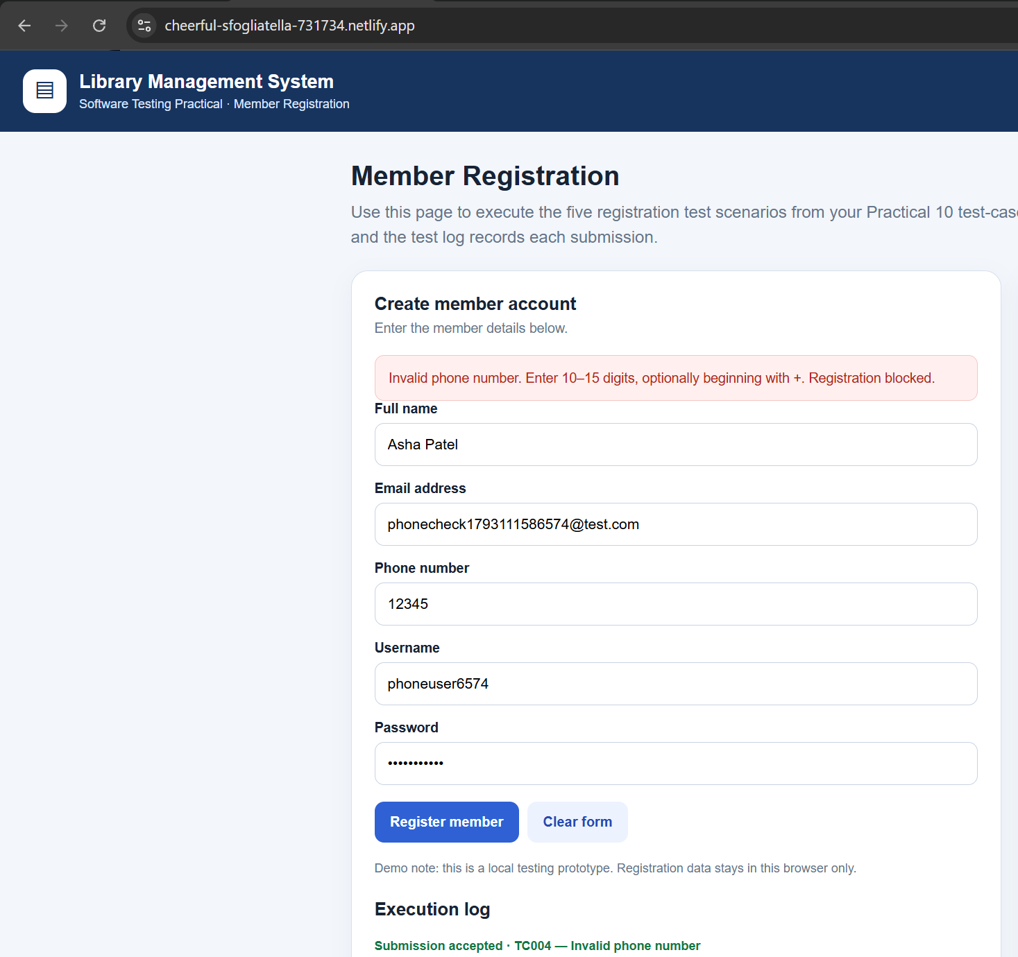

● Scenario ID: TC005
Scenario: Register member with whitespace-only inputs
Test Steps:
- 1. Open Member Registration
- 2. Enter only spaces in required fields
- 3. Click Register
Test Input: Spaces in all fields
Expected Result: Treated as empty; error shown
Actual Result: Whitespace-only inputs were treated as empty and validation errors were displayed.
Status: Pass
Comments: Whitespace validation
Screenshots:
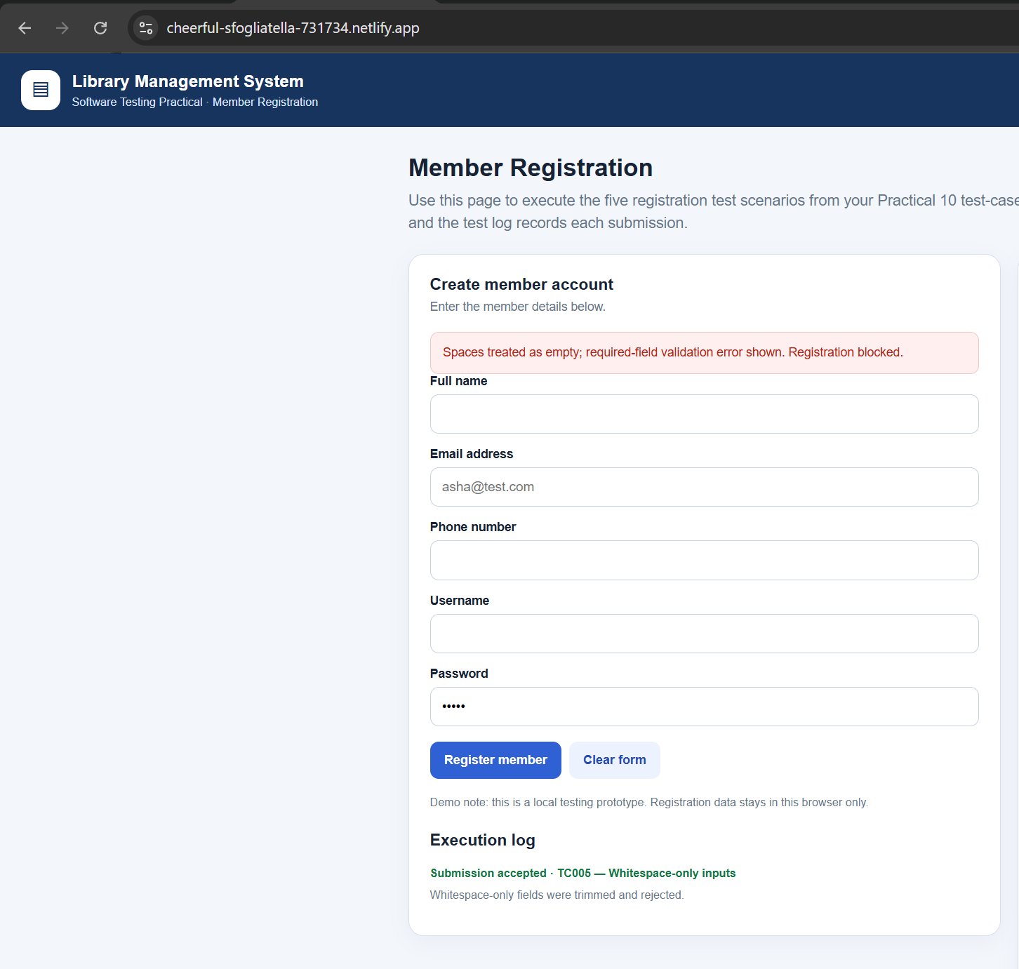
● Summary Of Test Results:
Total Test Cases | 5
Passed | 5
Failed | 0
Pass % | 100%

● Conclusion and Recommendations:
Pass Rate: 100% based on the sample actual results recorded in the Excel test-case sheet.
All five listed member-registration scenarios show Pass in the provided test-case sheet. The results should be confirmed by executing each scenario in the application.
● Recommendations:
- Verify the five scenarios against the running application and replace sample actual results if observed behavior differs.
- Keep validation messages clear for duplicate email, missing name, invalid phone number, and whitespace-only inputs.
- Attach screenshots showing the actual result for each scenario in the placeholders provided.

